Step1: sudo apt install qemu-kvm: This command is used for installing kvm.

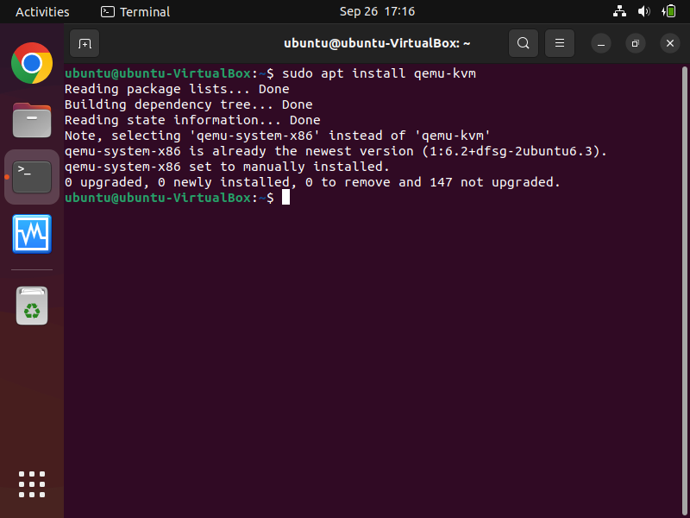

Step2: sudo kvm-ok: this command tell us weather we can use kvm or not.

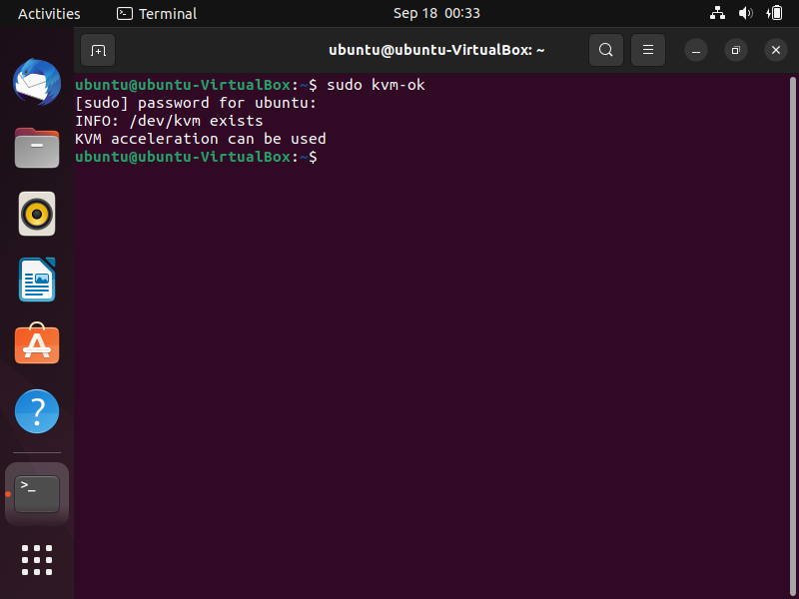

Step3: apt show qemu-system-x86: this command is used to check the version of qemu.

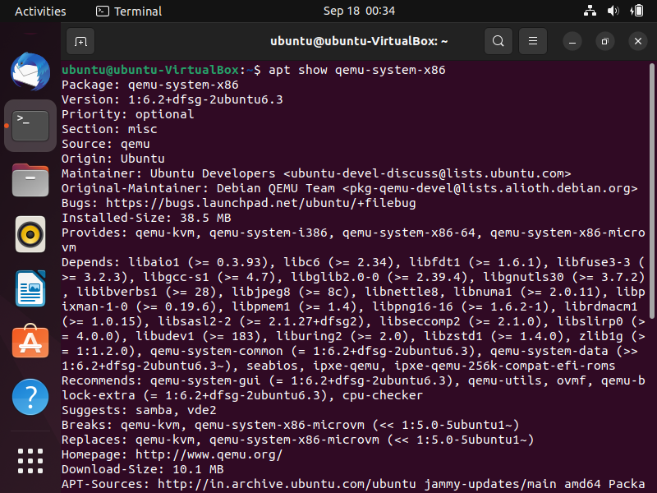

Step4: kvm -version: This command is used to check version of kvm installed in previous steps.

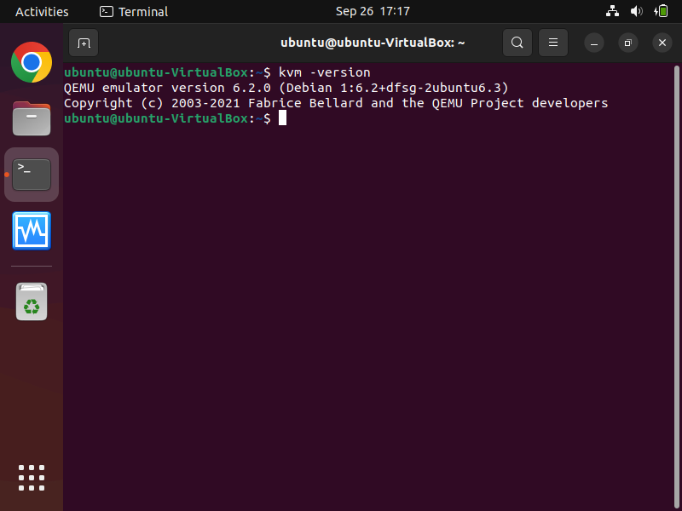

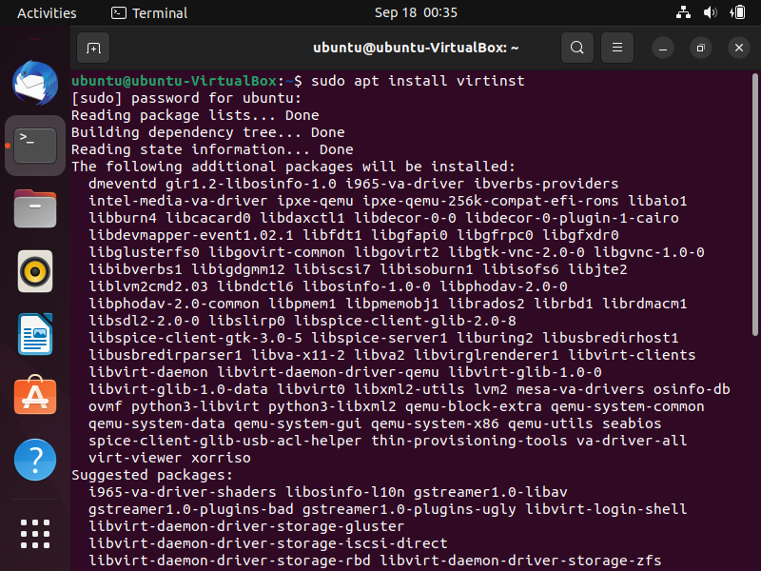Step5: sudo apt install virtinst: Used for installation of virtinst.

Step6: Wait till installation being completed.

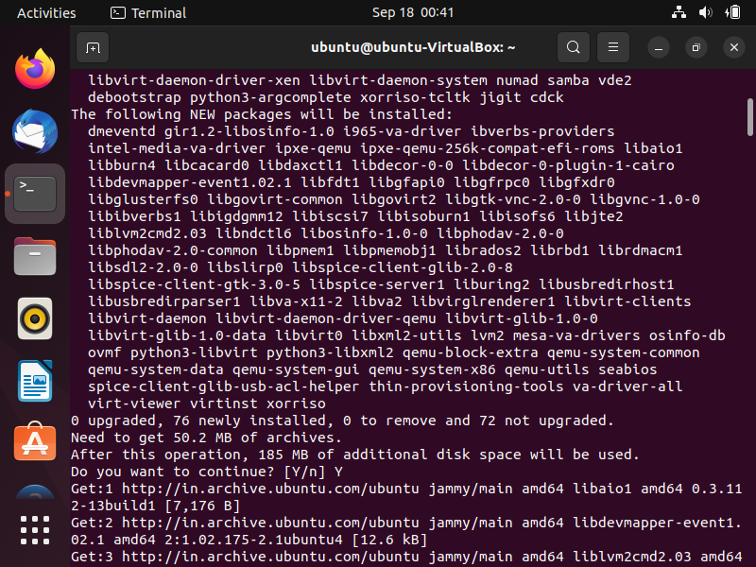

Step7: Progress bar showing the installation of virtinst.

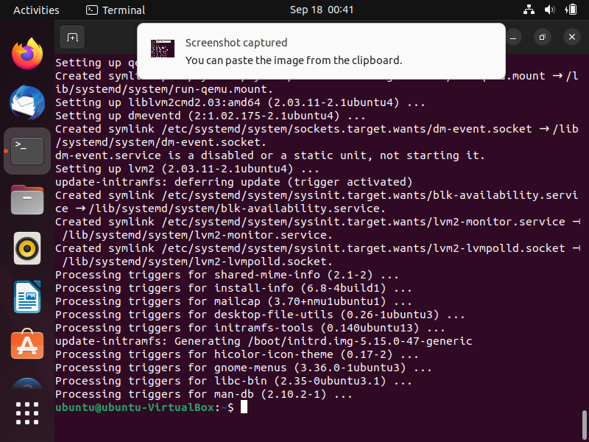

Step8: sudo apt install libvirt-daemon-system: Used for installation of libvirt. libvirt is a library, allowing you to use programming languages to configure virtual machines

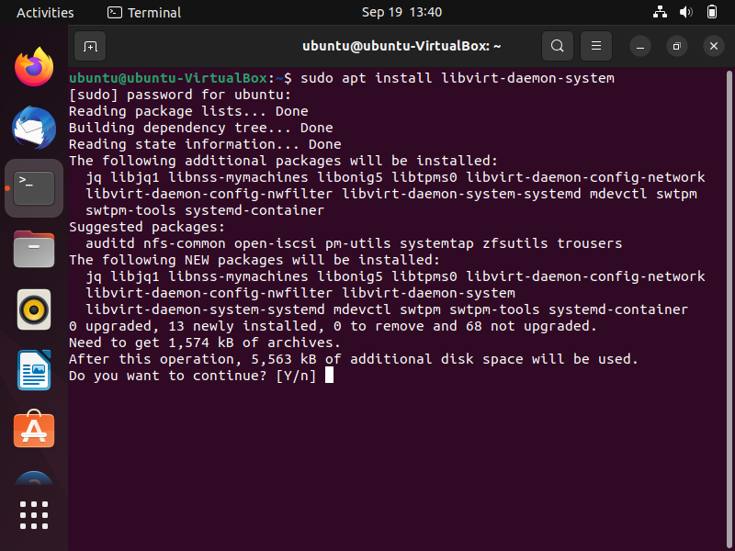

Step9: Wait till installation being completed. 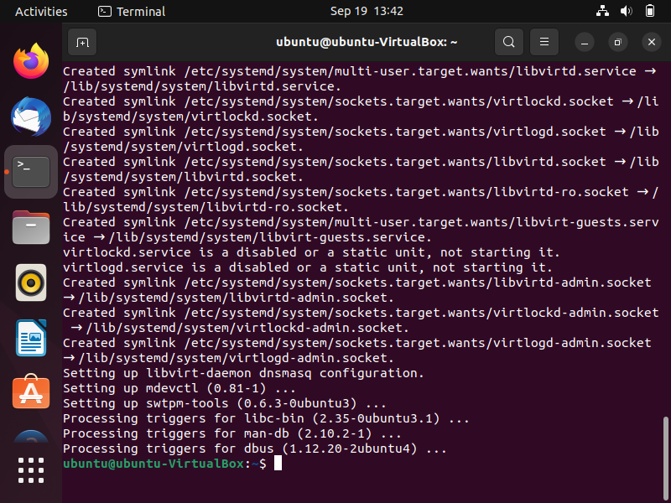

Step10: sudo apt install virt-manager: used for installation of virt-manamger. virt-manager provides an easy-to-use GUI similar to VMware/virtual box for managing virtual machines through libvirt.

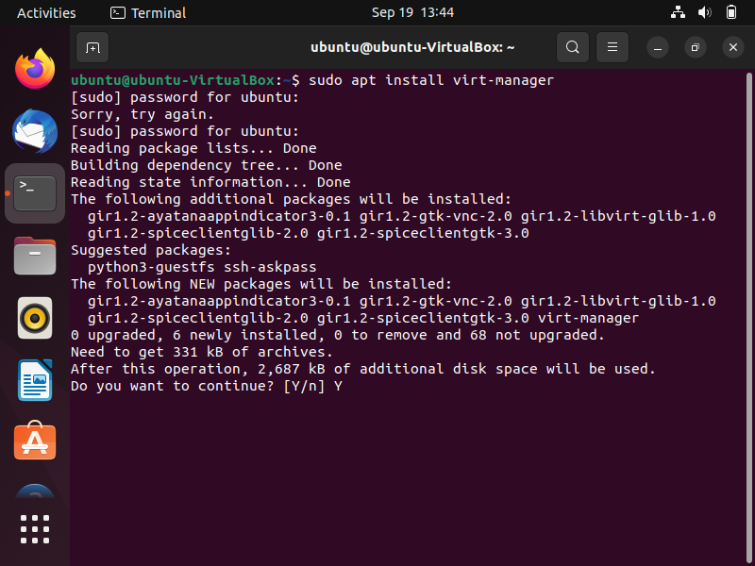

Step11: Wait till installation being completed. 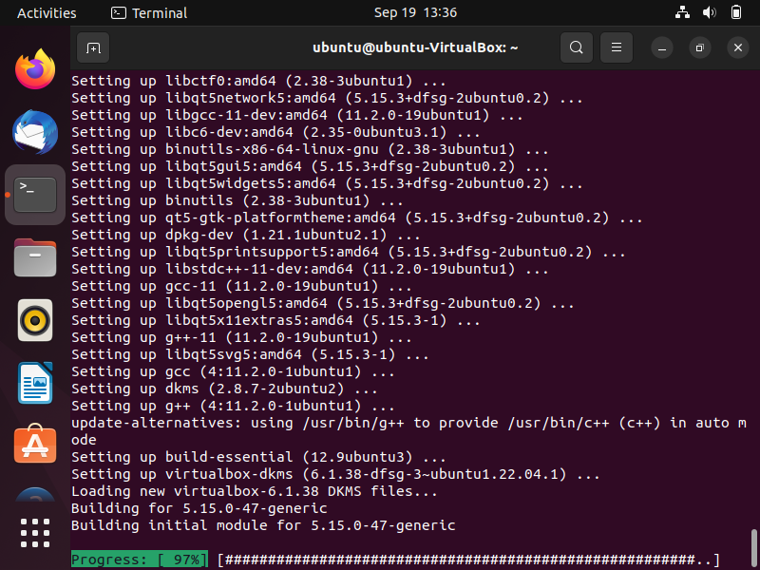

Step12: sudo lsmod | grep -i kvm: In case of amd cpu we will get kvm_amd module. From this command we able to create and manage virtual machines. 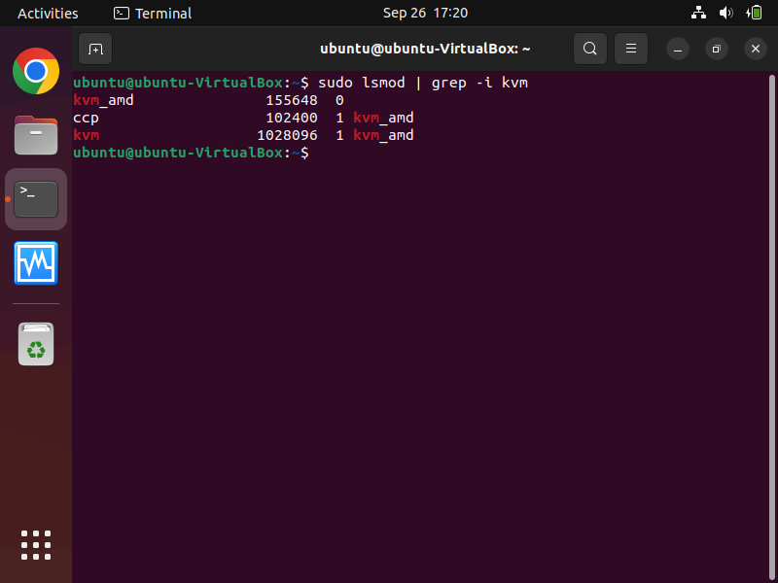Step13: The $USER environment variable points to the name of the currently logged-in user. To apply this change, we need to log out and log back again.

